[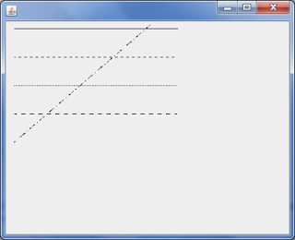](http://4.bp.blogspot.com/-5sNKC4W9nrE/UaDK7xkcK5I/AAAAAAAACC0/bq8tPV9-S28/s1600/atribut+garis.png)

Scriptnya bisa sobat cobas dibawwah ini :

public class MencobaAtributGaris extends javax.swing.JFrame {

public void paint(Graphics g){

    super.paint(g);

    Graphics2D g2d = (Graphics2D)g;

    float[] dash1 ={2f,0f,2f};

    float[] dash2 ={1f,1f,1f};

    float[] dash3 ={4f,0f,2f};

    float[] dash4 ={4f,4f,1f};

    g2d.drawLine(20,40,250,40);

    BasicStroke bs1 = new BasicStroke(1,

            BasicStroke.CAP_BUTT,

            BasicStroke.JOIN_ROUND,1.0f,dash1,2f);

    BasicStroke bs2 = new BasicStroke(1,

            BasicStroke.CAP_BUTT,

            BasicStroke.JOIN_ROUND,1.0f,dash2,2f);

    BasicStroke bs3 = new BasicStroke(1,

            BasicStroke.CAP_BUTT,

            BasicStroke.JOIN_ROUND,1.0f,dash3,2f);

    BasicStroke bs4 = new BasicStroke(1,

            BasicStroke.CAP_BUTT,

            BasicStroke.JOIN_ROUND,1.0f,dash4,2f);

    g2d.setStroke(bs1);

    g2d.drawLine(20,80,250,80);

    g2d.setStroke(bs2);

    g2d.drawLine(20,120,250,120);

    g2d.setStroke(bs3);

    g2d.drawLine(20,160,250,160);

    g2d.setStroke(bs4);

    g2d.drawLine(20,200,250,2);

}